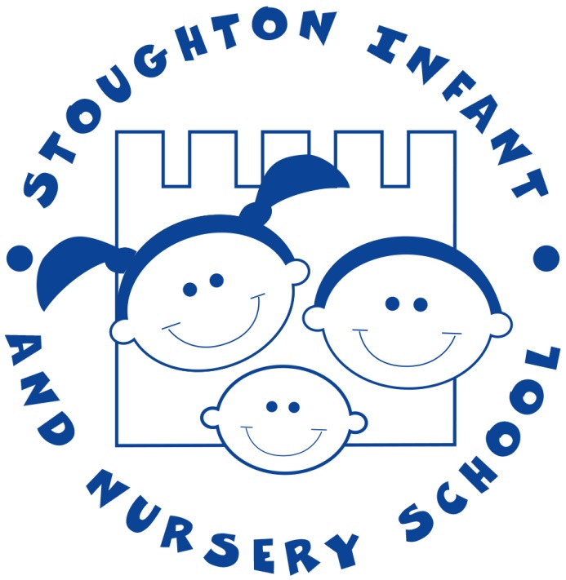

Nursery Admissions Policy
2021-2022

A child will be eligible for admission to the nursery from the term after they turn 3 years old. Admission will be subject to an application being made and places available.
There is one Nursery intake in September. Children will only be admitted at other points in the year, if spaces become available.
All 3 and 4 year old children are eligible for a funded 15 hour Nursery place.
Some children may be eligible for a funded 30 hour Nursery place. Please follow the link to check your eligibility: https://www.gov.uk/help-with-childcare-costs/free-childcare-and-education-for-2-to-4-year-olds
If you’re not eligible for 30 hours funded childcare, you may top up to the full 30 hours, at a charge of £15 per session (a session is a morning or afternoon) or £30 per day. Top up sessions are not available ad-hoc and they need to be a regular commitment, which is paid in advance.
We offer:
- 30 hour places, Monday to Friday, 8.50am to 2.50pm
- 15 hour places, Monday and Tuesday, 8.50am to 2.50pm and Wednesday 8.50am-11.50am
- 15 hour places, Wednesday 12pm-3pm, Thursday and Friday 8.50am -2.50pm
Nursery Start Date | Application Deadline | Notification
September 2021 | 12th March 2021 | 23rd April 2021

The admission of Nursery children is delegated to the Governing Body of Stoughton Infant School.
The Nursery will endeavour to inform parents of the outcome of their application by the notification date. If a parent is offered a place they must confirm acceptance directly with the school by the date stipulated in their offer letter.
Priority will be given to children starting school in the next academic year and therefore in their last year of pre-school. Should there be more applications than spaces available we will use the school’s admission criteria. In summary, the admission criteria are:
1. Looked after and previously looked after children.
2. Exceptional social/medical need.
3. Children who will have a sibling at the school or at an infant/junior school which operates shared sibling priority, at the time of the child’s admission.
4. Staff Children
5. Any other children, prioritised according to the distance they live from the school.
If in the unlikely circumstance that the nursery isn’t full after applying criterion 1-5, we will offer places to children after their 3rd birthday in date of birth order. This place will be charged at a rate of £15 per session. Parents will be charged from their child’s first day in nursery until they’re eligible and in receipt of funding from the government (the term after the child turns 3). We can accept FEET funding or range of childcare vouchers for this period of time.
The final decision with regard to admissions and the allocation of sessions will rest with the Governing Body of the school.
Admission to the school’s nursery does not guarantee admission to the Reception class of Stoughton Infant School. Application for a Reception place at the school must be made through Surrey’s Admissions Scheme by the published deadline in order to be considered.
If it becomes apparent at any time that a parent/carer has made a fraudulent or intentionally misleading application, which has effectively denied a place to another child, the governors reserve the right to withdraw the place.
Guidance Notes
‘Looked after’ children are in the care of a local authority or being provided with accommodation by a local authority in the exercise of their social services function at the time of making an application to the Nursery; ‘previously looked after children’ are any children who were looked after, but ceased to be so because they were adopted (or became subject to a child arrangement order or special guardianship order). A letter from the Children’s Services Department confirming the child’s status must be submitted at the time of application.
Applications made on medical or other grounds:
If, at the time of application, a child has a serious or life-threatening medical condition which the parent considers makes attendance at this Nursery essential, this must be stated on the application form and will only be considered if substantive medical evidence is attached. Please note: a letter from a GP will not normally be deemed as sufficient medical evidence.
If there are sensitive and/or serious individual and/or family circumstances which the parent considers makes attendance at this Nursery essential, these must be stated on the application form. Substantive evidence will need to be provided at the time of application, such as a report from a support service.
Occasionally, there will be a very small number of children for whom exceptional social need will apply which will warrant a placement at a particular nursery. The exceptional social circumstances might relate to either the child or the parent or carer. Supporting evidence from a professional is required such as a doctor and/or consultant for medical cases or a social worker, health visitor, housing officer, the police or probation officer for other social circumstances. This evidence must confirm the circumstances of the case and must set out why the child should attend. (Providing evidence does not guarantee that a child will be given priority and in each case a decision will be made based on the merits of the case).
A child will be given sibling priority if they have a sibling on roll at Stoughton Infant School or Northmead Junior School and that sibling is still expected to be on roll at either school at the time of the child’s admission. This will apply both at the initial allocation of places and also when prioritising the waiting list. At the initial allocation, when an applicant is applying for a Reception place and the child has a sibling currently attending Year 2 but who will have left by the time the younger child starts, the younger child will be considered under the sibling criterion as part of the initial allocation. This is because, due to the feeder link with Northmead Junior School, they will be expected to still have a sibling on roll at the time of admission.
Staff Children Priority is given to the children of staff who have been employed at the school for two or more years. The date that will be used to assess the length of time that a member of staff has been employed will be the closing date for applications. “Staff children” applies to any member of staff that is employed for Stoughton Infant School.

